Modèle Conceptuel de Données

Plateforme de Covoiturage

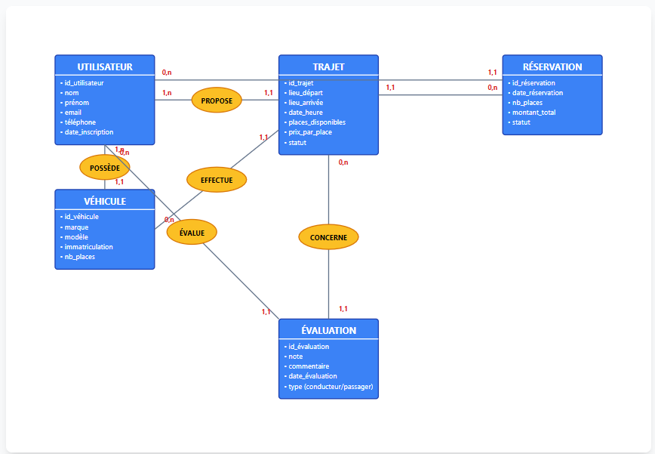

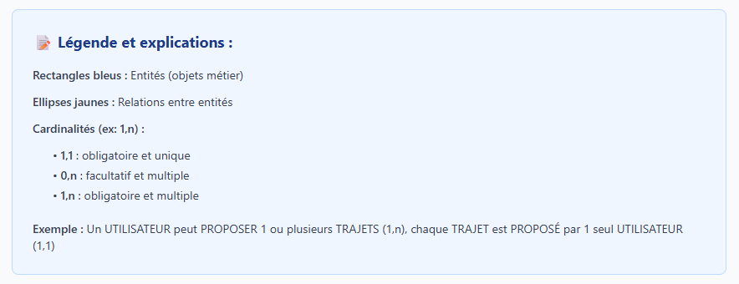

import React from 'react';

export default function MCDCovoiturage() {
return (
<div className="w-full h-screen bg-gray-50 p-8 overflow-auto">
<div className="max-w-7xl mx-auto">
<h1 className="text-3xl font-bold text-gray-800 mb-2">Modèle Conceptuel de Données</h1>
<h2 className="text-xl text-gray-600 mb-8">Plateforme de Covoiturage</h2>

<div className="bg-white p-8 rounded-lg shadow-lg">
<svg viewBox="0 0 1200 800" className="w-full">
{/* UTILISATEUR */}
<g>
<rect x="50" y="50" width="200" height="180" fill="#3b82f6" stroke="#1e40af" strokeWidth="2" rx="5"/>
<text x="150" y="80" textAnchor="middle" fill="white" fontSize="18" fontWeight="bold">UTILISATEUR</text>
<line x1="50" y1="90" x2="250" y2="90" stroke="white" strokeWidth="2"/>
<text x="60" y="110" fill="white" fontSize="14">• id_utilisateur</text>
<text x="60" y="130" fill="white" fontSize="14">• nom</text>
<text x="60" y="150" fill="white" fontSize="14">• prénom</text>
<text x="60" y="170" fill="white" fontSize="14">• email</text>
<text x="60" y="190" fill="white" fontSize="14">• téléphone</text>
<text x="60" y="210" fill="white" fontSize="14">• date_inscription</text>
</g>

{/* VÉHICULE */}
<g>
<rect x="50" y="320" width="200" height="160" fill="#3b82f6" stroke="#1e40af" strokeWidth="2" rx="5"/>
<text x="150" y="350" textAnchor="middle" fill="white" fontSize="18" fontWeight="bold">VÉHICULE</text>
<line x1="50" y1="360" x2="250" y2="360" stroke="white" strokeWidth="2"/>
<text x="60" y="380" fill="white" fontSize="14">• id_véhicule</text>
<text x="60" y="400" fill="white" fontSize="14">• marque</text>
<text x="60" y="420" fill="white" fontSize="14">• modèle</text>
<text x="60" y="440" fill="white" fontSize="14">• immatriculation</text>
<text x="60" y="460" fill="white" fontSize="14">• nb_places</text>
</g>

{/* TRAJET */}
<g>
<rect x="500" y="50" width="200" height="200" fill="#3b82f6" stroke="#1e40af" strokeWidth="2" rx="5"/>
<text x="600" y="80" textAnchor="middle" fill="white" fontSize="18" fontWeight="bold">TRAJET</text>
<line x1="500" y1="90" x2="700" y2="90" stroke="white" strokeWidth="2"/>
<text x="510" y="110" fill="white" fontSize="14">• id_trajet</text>
<text x="510" y="130" fill="white" fontSize="14">• lieu_départ</text>
<text x="510" y="150" fill="white" fontSize="14">• lieu_arrivée</text>
<text x="510" y="170" fill="white" fontSize="14">• date_heure</text>
<text x="510" y="190" fill="white" fontSize="14">• places_disponibles</text>
<text x="510" y="210" fill="white" fontSize="14">• prix_par_place</text>
<text x="510" y="230" fill="white" fontSize="14">• statut</text>
</g>

{/* RÉSERVATION */}
<g>
<rect x="950" y="50" width="200" height="160" fill="#3b82f6" stroke="#1e40af" strokeWidth="2" rx="5"/>
<text x="1050" y="80" textAnchor="middle" fill="white" fontSize="18" fontWeight="bold">RÉSERVATION</text>
<line x1="950" y1="90" x2="1150" y2="90" stroke="white" strokeWidth="2"/>
<text x="960" y="110" fill="white" fontSize="14">• id_réservation</text>
<text x="960" y="130" fill="white" fontSize="14">• date_réservation</text>
<text x="960" y="150" fill="white" fontSize="14">• nb_places</text>
<text x="960" y="170" fill="white" fontSize="14">• montant_total</text>
<text x="960" y="190" fill="white" fontSize="14">• statut</text>
</g>

{/* ÉVALUATION */}
<g>
<rect x="500" y="580" width="200" height="160" fill="#3b82f6" stroke="#1e40af" strokeWidth="2" rx="5"/>
<text x="600" y="610" textAnchor="middle" fill="white" fontSize="18" fontWeight="bold">ÉVALUATION</text>
<line x1="500" y1="620" x2="700" y2="620" stroke="white" strokeWidth="2"/>
<text x="510" y="640" fill="white" fontSize="14">• id_évaluation</text>
<text x="510" y="660" fill="white" fontSize="14">• note</text>
<text x="510" y="680" fill="white" fontSize="14">• commentaire</text>
<text x="510" y="700" fill="white" fontSize="14">• date_évaluation</text>
<text x="510" y="720" fill="white" fontSize="14">• type (conducteur/passager)</text>
</g>

{/* Relation POSSÈDE (Utilisateur-Véhicule) */}
<g>
<path d="M 150 230 L 150 320" stroke="#64748b" strokeWidth="2" fill="none"/>
<ellipse cx="150" cy="275" rx="50" ry="25" fill="#fbbf24" stroke="#d97706" strokeWidth="2"/>
<text x="150" y="282" textAnchor="middle" fill="#000" fontSize="14" fontWeight="bold">POSSÈDE</text>
<text x="170" y="245" fill="#dc2626" fontSize="13" fontWeight="bold">1,n</text>
<text x="170" y="310" fill="#dc2626" fontSize="13" fontWeight="bold">1,1</text>
</g>

{/* Relation PROPOSE (Utilisateur-Trajet) */}
<g>
<path d="M 250 140 L 500 140" stroke="#64748b" strokeWidth="2" fill="none"/>
<ellipse cx="375" cy="140" rx="50" ry="25" fill="#fbbf24" stroke="#d97706" strokeWidth="2"/>
<text x="375" y="147" textAnchor="middle" fill="#000" fontSize="14" fontWeight="bold">PROPOSE</text>
<text x="265" y="130" fill="#dc2626" fontSize="13" fontWeight="bold">1,n</text>
<text x="470" y="130" fill="#dc2626" fontSize="13" fontWeight="bold">1,1</text>
</g>

{/* Relation EFFECTUE (Trajet-Véhicule) */}
<g>
<path d="M 500 200 L 250 400" stroke="#64748b" strokeWidth="2" fill="none"/>
<ellipse cx="375" cy="300" rx="60" ry="25" fill="#fbbf24" stroke="#d97706" strokeWidth="2"/>
<text x="375" y="307" textAnchor="middle" fill="#000" fontSize="14" fontWeight="bold">EFFECTUE</text>
<text x="460" y="220" fill="#dc2626" fontSize="13" fontWeight="bold">1,1</text>
<text x="270" y="385" fill="#dc2626" fontSize="13" fontWeight="bold">0,n</text>
</g>

{/* Relation RÉSERVER (Utilisateur-Réservation-Trajet) */}
<g>
<path d="M 250 100 L 950 100" stroke="#64748b" strokeWidth="2" fill="none"/>
<path d="M 700 130 L 950 130" stroke="#64748b" strokeWidth="2" fill="none"/>
<text x="265" y="90" fill="#dc2626" fontSize="13" fontWeight="bold">0,n</text>
<text x="715" y="120" fill="#dc2626" fontSize="13" fontWeight="bold">1,1</text>
<text x="920" y="90" fill="#dc2626" fontSize="13" fontWeight="bold">1,1</text>
<text x="920" y="120" fill="#dc2626" fontSize="13" fontWeight="bold">0,n</text>
</g>

{/* Relation ÉVALUER (Utilisateur-Évaluation) */}
<g>
<path d="M 150 230 L 500 580" stroke="#64748b" strokeWidth="2" fill="none"/>
<ellipse cx="325" cy="405" rx="50" ry="25" fill="#fbbf24" stroke="#d97706" strokeWidth="2"/>
<text x="325" y="412" textAnchor="middle" fill="#000" fontSize="14" fontWeight="bold">ÉVALUE</text>
<text x="180" y="250" fill="#dc2626" fontSize="13" fontWeight="bold">0,n</text>
<text x="465" y="570" fill="#dc2626" fontSize="13" fontWeight="bold">1,1</text>
</g>

{/* Relation CONCERNE (Évaluation-Trajet) */}
<g>
<path d="M 600 250 L 600 580" stroke="#64748b" strokeWidth="2" fill="none"/>
<ellipse cx="600" cy="415" rx="60" ry="25" fill="#fbbf24" stroke="#d97706" strokeWidth="2"/>
<text x="600" y="422" textAnchor="middle" fill="#000" fontSize="14" fontWeight="bold">CONCERNE</text>
<text x="620" y="270" fill="#dc2626" fontSize="13" fontWeight="bold">0,n</text>
<text x="620" y="565" fill="#dc2626" fontSize="13" fontWeight="bold">1,1</text>
</g>
</svg>
</div>

<div className="mt-8 bg-blue-50 p-6 rounded-lg border border-blue-200">
<h3 className="text-lg font-bold text-blue-900 mb-4">📝 Légende et explications :</h3>
<div className="space-y-3 text-sm text-gray-700">
<div><span className="font-semibold">Rectangles bleus :</span> Entités (objets métier)</div>
<div><span className="font-semibold">Ellipses jaunes :</span> Relations entre entités</div>
<div><span className="font-semibold">Cardinalités (ex: 1,n) :</span></div>
<ul className="ml-6 space-y-1">
<li>• <span className="font-semibold">1,1</span> : obligatoire et unique</li>
<li>• <span className="font-semibold">0,n</span> : facultatif et multiple</li>
<li>• <span className="font-semibold">1,n</span> : obligatoire et multiple</li>
</ul>
<div className="pt-2"><span className="font-semibold">Exemple :</span> Un UTILISATEUR peut PROPOSER 1 ou plusieurs TRAJETS (1,n), chaque TRAJET est PROPOSÉ par 1 seul UTILISATEUR (1,1)</div>
</div>
</div>
</div>
</div>
);
}

